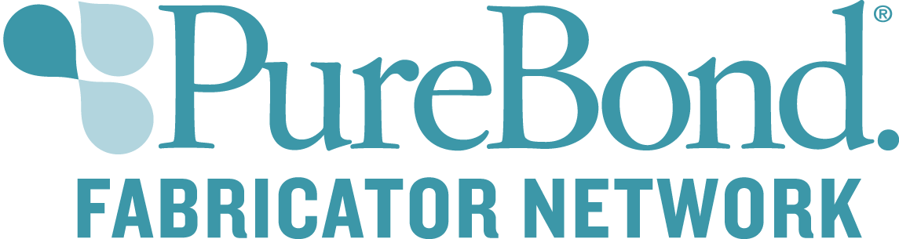

2018 PureBond Quality Awards Entry Form

Please fill out the form below and return along with between two to six hi-resolution images (at least 300 dpi at 4x6" size; or 72 dpi at 16x24" size). JPG or TIF formats preferred. Email form and photos to jfrench@cfpwood.com by July 14, 2018.

(LIMIT 6 PHOTOS. SEND SEPARATELY IF NECESSARY.)

Please complete all fields. Write as much as you like. Deadline for entries will be July 14, 2018. Please type your answers in the spaces provided and email this word document and supporting photos to jfrench@cfpwood.com Sorry, no handwritten forms can be accepted.
REQUIRED INFORMATION: PLEASE FILL OUT THE SECTION IN BLUE.
Company Name:

Contact Name (in case we have follow up questions):

Contact Email:

Company Address:

Phone:

Company Website:

Distributor the PureBond Plywood was purchased from:
PureBond product description (thickness, core type, face veneer species & grade):

Brief description of your shop and history:

Comments about the job submitted and date of installation:

Comments about how PureBond plywood met the needs of the client (Ex: American Hardwood beauty, No VOC’s, made in America, all wood construction, etc):

If you have questions, please contact Jack French: jfrench@cfpwood.com

